BIOS 7659 Homework 6

Tim Vigers

02 November 2020

data("montgomery.subset")  
data("uCovar")

# 1. Next Generation Sequencing: Differential Expression

## a) Calculate RPKM and perform a t test

RPKM stands for reads per kilobases per million reads and is calculated by

$$\frac{r_{g}}{l_{g}T}=\frac{\text{\# of mapped reads}}{\text{length in Kb}*\text{total mapped reads in millions}}:$$

lg = uCovar$length / 1000  
t = sum(unlist(montgomery.subset))  
rpkm = montgomery.subset/(lg*t)

Do a standard t test between the groups for each gene:

# T test for each row  
t_tests = apply(rpkm,1,function(x){  
 group1 = as.numeric(x[1:5])  
 group2 = as.numeric(x[6:10])  
 if(var(group1)==0 | var(group2)==0){ # Skip those with constant values   
 return(c(NA,NA))  
 } else {  
 t <- t.test(group1,group2)  
 return(c(t$statistic,t$p.value))  
 }  
})  
# Format and print  
t_tests = as.data.frame(t(t_tests))  
t_tests = t_tests %>% rownames_to_column() %>%   
 set_names(c("Gene","T","p")) %>% arrange(desc(abs(T)))   
  
t_tests %>% head(10) %>% flextable(.) %>%   
 set_caption("Top 10 Genes by t-statistic") %>% autofit(.)

Top 10 Genes by t-statistic

| Gene | T | p |
| --- | --- | --- |
| ENSG00000245208 | 5.498052 | 0.0005766918 |
| ENSG00000228109 | 5.258951 | 0.0011172910 |
| ENSG00000158985 | -5.146613 | 0.0053740327 |
| ENSG00000175274 | 4.826005 | 0.0023624029 |
| ENSG00000154710 | 4.810702 | 0.0021405930 |
| ENSG00000197747 | 4.714045 | 0.0018518080 |
| ENSG00000170802 | -4.686417 | 0.0028152695 |
| ENSG00000125629 | -4.624472 | 0.0035333403 |
| ENSG00000185947 | -4.575696 | 0.0085521476 |
| ENSG00000005187 | -4.495972 | 0.0026741415 |

## b) Plot the histogram of p-values

hist(t_tests$p,main = "Histogram of p values",xlab = "p")

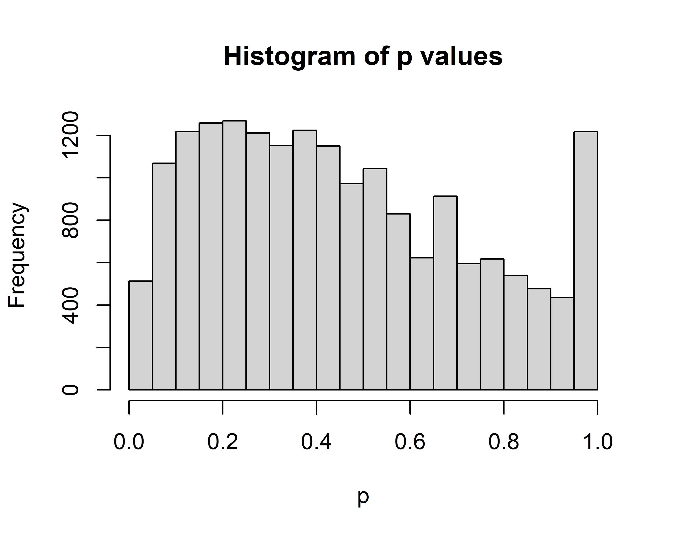

Normally we would expect a uniform distribution of p values, but this distribution appears to have a peak at around 0.3 and another at p = 1. My guess is that this is because we have only filtered genes with all 0 counts, but kept other genes with counts so low that they are effectively 0.

## c) Filter genes by total counts

# DOESN’T DGELIST AUTOMATICALLY INCLUDE lib.size

with the total reads per subject?

# Remove genes with low counts  
filtered = montgomery.subset[rowSums(montgomery.subset)>=10,]  
# Create edgeR object  
filtered_dge = DGEList(filtered,group = c(rep(1,5),rep(2,5)))

## d) Calculate TMM normalization factors

norm = calcNormFactors(filtered_dge)  
autofit(flextable(norm$samples))

| group | lib.size | norm.factors |
| --- | --- | --- |
| 1 | 2817342 | 0.9420009 |
| 1 | 2168185 | 1.0077134 |
| 1 | 2782270 | 0.9975042 |
| 1 | 2551303 | 0.9790312 |
| 1 | 4259582 | 0.9025138 |
| 2 | 1461731 | 1.1474002 |
| 2 | 5013427 | 1.0833630 |
| 2 | 3623044 | 0.9307130 |
| 2 | 6332824 | 0.9784469 |
| 2 | 3786172 | 1.0558556 |

The effective library sizes are generally similar to the column sums because the normalization factors are fairly close to 1. A normalization factor > 1 increases the library size, which is similar to downscaling the counts (and vice versa for factors < 1). So, the effective library size for sample 6 is increased by about 115%. Conversely, the effective library size for sample 5 is decreased by approximately 90%, which suggests that there are a small number of high-count sequences that need to be adjusted for.

## e) Use the estimateDisp() function to calculate the common, trended and tagwise dispersions

filtered_dge = estimateDisp(filtered_dge)

## Design matrix not provided. Switch to the classic mode.

The common dispersion estimate is approximately 0.349. Plot the tagwise dispersion estimate for each gene vs. the average log counts per million:

# IS IT OKAY TO USE THE BUILT IN FUNCTION THAT PLOTS ON SQUARE ROOT SCALE?

plotBCV(filtered_dge)

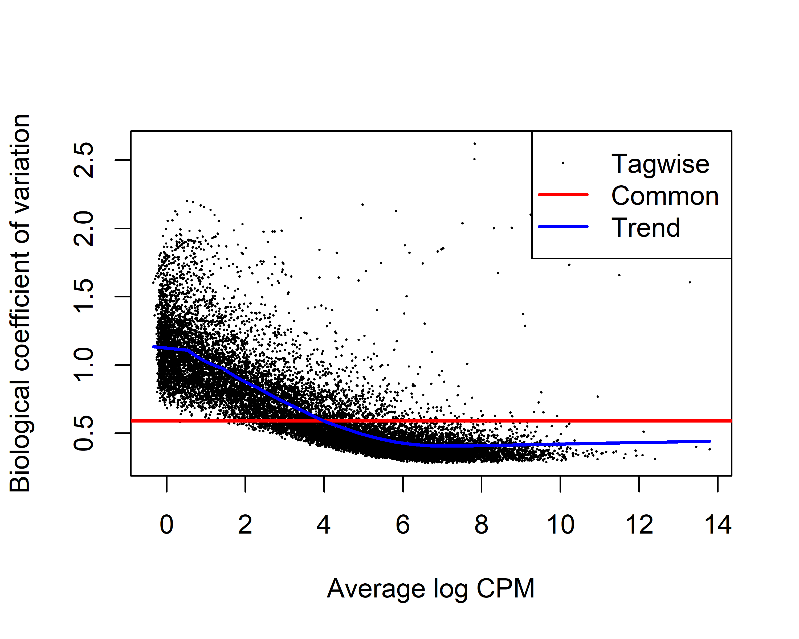

The common dispersion estimate only seems to work well for a narrow range of log CPM around 4. It appears to underestimate dispersion for the lower count genes and overestimate the higher average count genes.

## f) Fit the negative binomial model

### Using the common dispersion estimate

et <- exactTest(filtered_dge,dispersion = "common")  
top_common <- topTags(et) %>% as.data.frame(.) %>%   
 rownames_to_column(.,var = "Gene")  
autofit(flextable(top_common))

| Gene | logFC | logCPM | PValue | FDR |
| --- | --- | --- | --- | --- |
| ENSG00000211642 | -11.029384 | 6.504848 | 4.646432e-30 | 7.257727e-26 |
| ENSG00000211660 | -10.678692 | 6.162012 | 1.447959e-28 | 1.130856e-24 |
| ENSG00000211890 | -7.595350 | 10.228002 | 2.730213e-25 | 1.421531e-21 |
| ENSG00000211937 | -7.122400 | 6.050910 | 3.073339e-22 | 1.200139e-18 |
| ENSG00000211638 | 7.650287 | 5.058009 | 2.270402e-20 | 7.092736e-17 |
| ENSG00000243063 | -7.259087 | 5.828130 | 4.131889e-19 | 1.075668e-15 |
| ENSG00000211651 | 7.344597 | 3.878077 | 4.544282e-17 | 1.014024e-13 |
| ENSG00000238649 | 6.652599 | 4.320843 | 6.989085e-17 | 1.364619e-13 |
| ENSG00000211938 | 5.225677 | 7.022704 | 2.688483e-15 | 4.666012e-12 |
| ENSG00000253701 | 6.352338 | 3.786868 | 4.927015e-15 | 7.153687e-12 |

### Using the tag-wise dispersion estimates

et <- exactTest(filtered_dge,dispersion = "tagwise")  
top_tagwise <- topTags(et) %>% as.data.frame(.) %>%   
 rownames_to_column(.,var = "Gene")  
autofit(flextable(top_tagwise))

| Gene | logFC | logCPM | PValue | FDR |
| --- | --- | --- | --- | --- |
| ENSG00000253701 | 6.321934 | 3.786868 | 1.225411e-07 | 0.001914093 |
| ENSG00000211892 | -6.059085 | 2.662691 | 2.531525e-06 | 0.019771212 |
| ENSG00000134184 | -6.453312 | 1.042133 | 4.336917e-06 | 0.022580879 |
| ENSG00000239223 | 3.390230 | 3.261841 | 7.399928e-06 | 0.028896719 |
| ENSG00000148411 | -2.288891 | 5.087781 | 1.593862e-05 | 0.049792261 |
| ENSG00000211642 | -10.981435 | 6.504848 | 3.127496e-05 | 0.081419147 |
| ENSG00000180611 | 2.150017 | 5.272110 | 6.616724e-05 | 0.147647480 |
| ENSG00000211660 | -10.624115 | 6.162012 | 9.998158e-05 | 0.178008287 |
| ENSG00000189337 | -3.946439 | 4.040523 | 1.112568e-04 | 0.178008287 |
| ENSG00000023445 | 1.276689 | 7.313150 | 1.152851e-04 | 0.178008287 |

There are only 3 overlapping genes in the top 10 table for the two methods.Also, the top genes as determined by the common dispersion estimate approach appear to be driven more by fold change than those that are most significant using the tagwise method, because the table is essentially in decreasing order of logFC (with a couple of minor exceptions).

## g) Extract the raw counts

### For the top 10 genes based on the common dispersion

top_common_counts = filtered_dge$counts[top_common$Gene,] %>%  
 as.data.frame(.) %>% rownames_to_column(var = "Gene")  
set_table_properties(flextable(top_common_counts),  
 width = .5, layout = "autofit")

| Gene | NA06985 | NA06994 | NA07037 | NA10847 | NA11920 | NA11918 | NA11931 | NA12003 | NA12006 | NA12287 |
| --- | --- | --- | --- | --- | --- | --- | --- | --- | --- | --- |
| ENSG00000211642 | 0 | 1831 | 0 | 155 | 1 | 0 | 0 | 0 | 0 | 1 |
| ENSG00000211660 | 0 | 0 | 0 | 11 | 2994 | 0 | 0 | 0 | 0 | 1 |
| ENSG00000211890 | 0 | 2 | 0 | 3216 | 45407 | 53 | 9 | 29 | 86 | 15 |
| ENSG00000211937 | 0 | 0 | 0 | 630 | 1727 | 0 | 0 | 0 | 23 | 0 |
| ENSG00000211638 | 0 | 0 | 0 | 4 | 0 | 0 | 0 | 82 | 1889 | 1 |
| ENSG00000243063 | 0 | 0 | 0 | 1 | 2356 | 9 | 0 | 0 | 0 | 0 |
| ENSG00000211651 | 0 | 0 | 0 | 1 | 1 | 1 | 682 | 0 | 0 | 2 |
| ENSG00000238649 | 1 | 0 | 2 | 2 | 0 | 294 | 0 | 0 | 0 | 1 |
| ENSG00000211938 | 2 | 0 | 0 | 85 | 0 | 1791 | 0 | 14 | 243 | 8 |
| ENSG00000253701 | 0 | 0 | 0 | 4 | 0 | 77 | 8 | 134 | 33 | 138 |

# Most of these top genes have…

### For the top 10 genes based on tagwise dispersion

top_tagwise_counts = filtered_dge$counts[top_tagwise$Gene,] %>%  
 as.data.frame(.) %>% rownames_to_column(var = "Gene")  
set_table_properties(flextable(top_tagwise_counts),  
 width = .5, layout = "autofit")

| Gene | NA06985 | NA06994 | NA07037 | NA10847 | NA11920 | NA11918 | NA11931 | NA12003 | NA12006 | NA12287 |
| --- | --- | --- | --- | --- | --- | --- | --- | --- | --- | --- |
| ENSG00000253701 | 0 | 0 | 0 | 4 | 0 | 77 | 8 | 134 | 33 | 138 |
| ENSG00000211892 | 0 | 19 | 84 | 14 | 55 | 0 | 0 | 0 | 2 | 1 |
| ENSG00000134184 | 13 | 9 | 3 | 12 | 5 | 0 | 0 | 0 | 0 | 0 |
| ENSG00000239223 | 7 | 4 | 4 | 5 | 1 | 59 | 52 | 42 | 114 | 15 |
| ENSG00000148411 | 232 | 96 | 260 | 102 | 75 | 31 | 28 | 23 | 100 | 33 |
| ENSG00000211642 | 0 | 1831 | 0 | 155 | 1 | 0 | 0 | 0 | 0 | 1 |
| ENSG00000180611 | 6 | 16 | 76 | 48 | 60 | 88 | 350 | 131 | 277 | 381 |
| ENSG00000211660 | 0 | 0 | 0 | 11 | 2994 | 0 | 0 | 0 | 0 | 1 |
| ENSG00000189337 | 248 | 108 | 23 | 9 | 4 | 2 | 18 | 11 | 3 | 4 |
| ENSG00000023445 | 390 | 228 | 206 | 178 | 321 | 444 | 1397 | 785 | 921 | 673 |

# These are more evenly spread…

### Get Ensembl information for the top genes

#### Based on common dispersion

ensembl = useEnsembl(biomart="ensembl", dataset="hsapiens_gene_ensembl")  
en = getBM(attributes=c('ensembl_gene_id','description'),   
 filters ='ensembl_gene_id', values = top_common_counts$Gene,   
 mart = ensembl)  
set_table_properties(flextable(en),  
 width = .75, layout = "autofit")

| ensembl_gene_id | description |
| --- | --- |
| ENSG00000211638 | immunoglobulin lambda variable 8-61 [Source:HGNC Symbol;Acc:HGNC:5931] |
| ENSG00000211642 | immunoglobulin lambda variable 10-54 [Source:HGNC Symbol;Acc:HGNC:5884] |
| ENSG00000211651 | immunoglobulin lambda variable 1-44 [Source:HGNC Symbol;Acc:HGNC:5879] |
| ENSG00000211660 | immunoglobulin lambda variable 2-23 [Source:HGNC Symbol;Acc:HGNC:5890] |
| ENSG00000211890 | immunoglobulin heavy constant alpha 2 (A2m marker) [Source:HGNC Symbol;Acc:HGNC:5479] |
| ENSG00000211937 | immunoglobulin heavy variable 2-5 [Source:HGNC Symbol;Acc:HGNC:5576] |
| ENSG00000211938 | immunoglobulin heavy variable 3-7 [Source:HGNC Symbol;Acc:HGNC:5620] |
| ENSG00000238649 | small nucleolar RNA, C/D box 42A [Source:HGNC Symbol;Acc:HGNC:10180] |
| ENSG00000243063 | immunoglobulin kappa variable 3-7 (non-functional) [Source:HGNC Symbol;Acc:HGNC:5821] |

#### Based on tagwise dispersion

en = getBM(attributes=c('ensembl_gene_id','description'),   
 filters ='ensembl_gene_id', values = top_tagwise_counts$Gene,   
 mart = ensembl)  
set_table_properties(flextable(en),  
 width = .75, layout = "autofit")

| ensembl_gene_id | description |
| --- | --- |
| ENSG00000023445 | baculoviral IAP repeat containing 3 [Source:HGNC Symbol;Acc:HGNC:591] |
| ENSG00000134184 | glutathione S-transferase mu 1 [Source:HGNC Symbol;Acc:HGNC:4632] |
| ENSG00000148411 | NACC family member 2 [Source:HGNC Symbol;Acc:HGNC:23846] |
| ENSG00000180611 | Mab-21 domain containing 2 [Source:HGNC Symbol;Acc:HGNC:30438] |
| ENSG00000189337 | kazrin, periplakin interacting protein [Source:HGNC Symbol;Acc:HGNC:29173] |
| ENSG00000211642 | immunoglobulin lambda variable 10-54 [Source:HGNC Symbol;Acc:HGNC:5884] |
| ENSG00000211660 | immunoglobulin lambda variable 2-23 [Source:HGNC Symbol;Acc:HGNC:5890] |
| ENSG00000211892 | immunoglobulin heavy constant gamma 4 (G4m marker) [Source:HGNC Symbol;Acc:HGNC:5528] |
| ENSG00000239223 | ribosomal protein L34 pseudogene 31 [Source:HGNC Symbol;Acc:HGNC:36899] |